Reinforcement Learning in LLM

There are different types of Reinforcement Learning techniques used in building LLMs.
Widely adopted methods such as Reinforcement Learning from Human Feedback (RLHF) and Direct Preference Optimization (DPO) finetune pre-trained models to follow instructions and reflect human preferences.

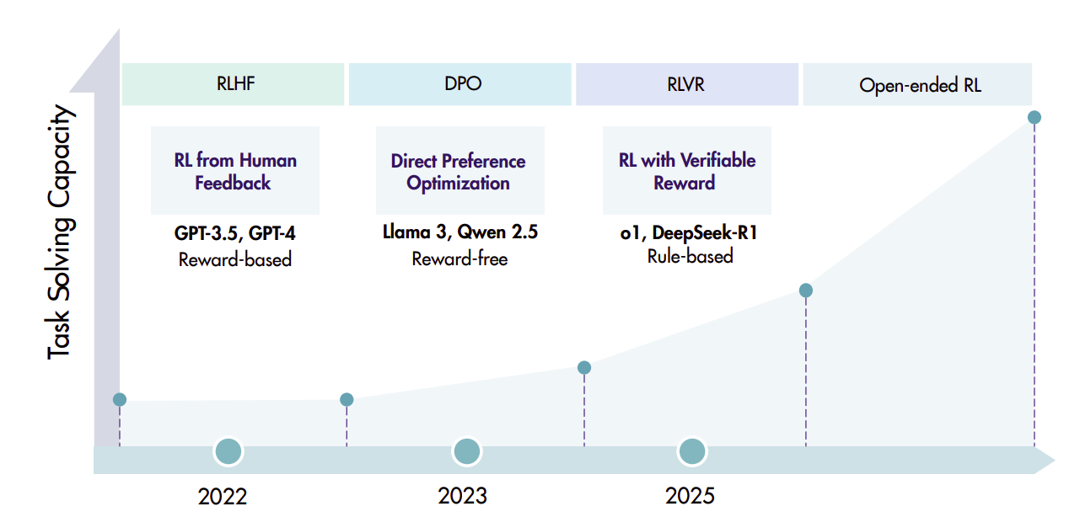

RLHF uses PPO (Proximal Policy Optimization).

PPO

Running code ppo.py gives us an idea of PPO clipping.

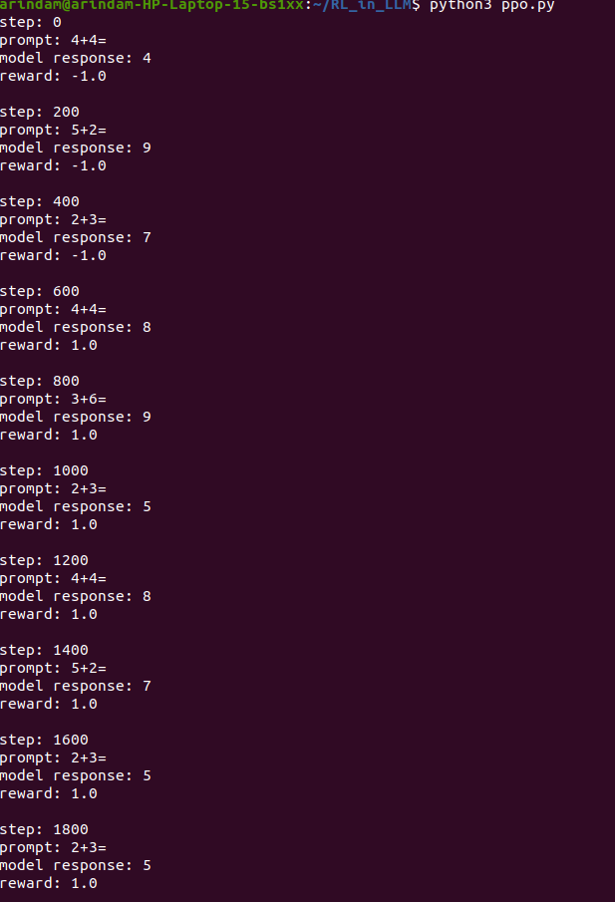
This script contains all PPO components used in RLHF.

Policy network
policy_head
Generates tokens.

Value network (critic)
value_head
Predicts expected reward.

Reward
reward_fn()
External signal.

Advantage
advantage = reward - value
Measures how good the action was.

PPO clipping
ratio = exp(new_logprob - old_logprob)
clipped_ratio = clamp(...)
Prevents large policy updates.

Real RLHF systems (used in early ChatGPT models) do the same loop:
prompt
↓
generate response
↓
reward model
↓
PPO update
The only differences:
Demo | Real systems
tiny RNN | huge transformers
simple reward | reward model
1 token output | long text
Let’s move on to GRPO now.

GRPO
GRPO is an RL algorithm.
For each prompt the model samples multiple responses and compares them.
Example:
Prompt: Solve this math problem

y1 → reward = 0
y2 → reward = 1
y3 → reward = 0
y4 → reward = 0
Then GRPO computes relative advantages inside the group:
Ai=ri−μGσGA_i = \frac{r_i - \mu_G}{\sigma_G}Ai​=σG​ri​−μG​​
where μ is the group average reward.
This advantage is used in a policy gradient update.
So GRPO is still reinforcement learning, just without a critic.
Signal = reward function
Example reward:
- correct answer → 1
- incorrect → 0
or
- code passes tests → reward
The model must explore outputs and learn via reward.
GRPO requires sampling outputs during training
prompt
→ generate 8–16 responses
→ compute reward
→ RL update
So it is online RL training.
GRPO is widely used in reasoning models (e.g. math/coding).
Key reasons:
- works with verifiable rewards
- no critic model required
- more memory efficient than PPO
- good for reasoning exploration
Many reasoning models like DeepSeek-R1 rely on GRPO-style RL.
GRPO Pipeline
Prompt
↓
Generate multiple outputs
↓
Score outputs (reward)
↓
Compute relative advantages
↓
Policy gradient update

Use GRPO when
- reward is automatically verifiable
- you want exploration
- you train reasoning models
Example rewards:
- math answer correct
- code passes tests
- proof verifies
The main difference between GRPO and PPO techniques are-

PPO
prompt
↓
generate response
↓
reward
↓
value network estimates expected reward
↓
advantage = reward − value
↓
policy update
Needs a critic (value network).

GRPO
prompt
↓
generate multiple responses
↓
compute rewards
↓
compare rewards within group
↓
advantage = normalized group reward
↓
policy update
No critic needed.
That’s why GRPO is simpler and more memory efficient.
Run grpo.py for GRPO demo. The output is like this:

$ python3 grpo.py
step: 0
prompt: 2+3=
sample: 1 reward: -1.0
sample: reward: -1.0
sample: 8 reward: -1.0
sample: 6 reward: -1.0
sample: 0 reward: -1.0
sample: 4 reward: -1.0
mean reward: -1.0

step: 200
prompt: 5+2=
sample: 7 reward: 1.0
sample: 7 reward: 1.0
sample: 7 reward: 1.0
sample: 7 reward: 1.0
sample: 7 reward: 1.0
sample: 7 reward: 1.0
mean reward: 1.0

step: 400
prompt: 2+3=
sample: 5 reward: 1.0
sample: 5 reward: 1.0
sample: 5 reward: 1.0
sample: 5 reward: 1.0
sample: 5 reward: 1.0
sample: 5 reward: 1.0
mean reward: 1.0

step: 600
prompt: 5+2=
sample: 7 reward: 1.0
sample: 7 reward: 1.0
sample: 7 reward: 1.0
sample: 7 reward: 1.0
sample: 7 reward: 1.0
sample: 7 reward: 1.0
mean reward: 1.0

step: 800
prompt: 4+4=
sample: 8 reward: 1.0
sample: 8 reward: 1.0
sample: 8 reward: 1.0
sample: 8 reward: 1.0
sample: 8 reward: 1.0
sample: 8 reward: 1.0
mean reward: 1.0

step: 1000
prompt: 3+6=
sample: 9 reward: 1.0
sample: 9 reward: 1.0
sample: 9 reward: 1.0
sample: 9 reward: 1.0
sample: 9 reward: 1.0
sample: 9 reward: 1.0
mean reward: 1.0

step: 1200
prompt: 5+2=
sample: 7 reward: 1.0
sample: 7 reward: 1.0
sample: 7 reward: 1.0
sample: 7 reward: 1.0
sample: 7 reward: 1.0
sample: 7 reward: 1.0
mean reward: 1.0

step: 1400
prompt: 3+6=
sample: 9 reward: 1.0
sample: 9 reward: 1.0
sample: 9 reward: 1.0
sample: 9 reward: 1.0
sample: 9 reward: 1.0
sample: 9 reward: 1.0
mean reward: 1.0

step: 1600
prompt: 3+6=
sample: 9 reward: 1.0
sample: 9 reward: 1.0
sample: 9 reward: 1.0
sample: 9 reward: 1.0
sample: 9 reward: 1.0
sample: 9 reward: 1.0
mean reward: 1.0

step: 1800
prompt: 4+4=
sample: 8 reward: 1.0
sample: 8 reward: 1.0
sample: 8 reward: 1.0
sample: 8 reward: 1.0
sample: 8 reward: 1.0
sample: 8 reward: 1.0
mean reward: 1.0

What Changed Compared to PPO
Component | PPO | GRPO
value network | ✔ | ❌
critic training | ✔ | ❌
multiple samples | optional | ✔
advantage source | value function | group statistics
Memory usage is smaller in GRPO.

Why GRPO Works Well for Reasoning
Suppose model generates:
2+3=
Group outputs:
5
6
7
5
4
5
Rewards:
[1,0,0,1,0,1]
Normalized advantages:
[+,+,-,+,-,+]
The model learns:
increase probability of "5"
decrease others
No critic required.

The code demonstrates the same core idea used in reasoning models like:
- DeepSeek-R1
- DeepSeek-R1-Zero
Their pipeline is basically:
pretraining
↓
instruction tuning
↓
RLVR training
↓
GRPO optimization

Now let us then understand RLVR

RLVR
RLVR = Reinforcement Learning with Verifiable Rewards.
Instead of learning from human preferences, the model learns from objective correctness signals.
Example tasks:
Task | Verifier
math | check final answer
coding | run unit tests
logic puzzle | compare with ground truth
structured output | format checker
Why RLVR Became Popular
Earlier systems used RLHF (Reinforcement Learning from Human Feedback).
RLHF pipeline:
human comparisons
↓
reward model
↓
RL optimization
Problems:
- expensive human labeling
- reward model can be gamed
- noisy signals
RLVR replaces that with objective rewards:
math correctness
code execution
formal verification
This gives:
- cheaper training
- longer RL runs
- better reasoning behavior
Many 2025 reasoning models rely on this paradigm.
RLVR still needs an RL algorithm.
Common ones:
Algorithm | Used in RLVR?
PPO | yes
GRPO | yes
variants (GSPO etc.) | yes
DeepSeek-R1 specifically used GRPO.
GRPO works like this:
- Generate multiple responses for a prompt
- Compute rewards
- Compare them relative to each other
Why RLVR Produces Reasoning
A surprising effect discovered with DeepSeek-R1-Zero:
They trained a model using:
RLVR
+
math problems
+
binary reward
No reasoning examples.
Yet the model started doing:
- step-by-step reasoning
- backtracking
- self-verification
Why?
Because reasoning increases probability of correct answers, so RL reinforces it.
So reasoning emerges as a strategy.

Typical RLVR Training Pipeline
Real systems look roughly like this:
Pretraining
↓
Instruction tuning
↓
RLVR phase
↓
Reasoning model
During RLVR:
prompt
↓
generate N responses
↓
verifier
↓
reward
↓
GRPO update

Why RLVR Works Best for Reasoning Tasks
RLVR requires verifiable outcomes.
Good domains:
- math
- code
- logic puzzles
- theorem proving
- tool usage
Bad domains:
- creative writing
- empathy
- subjective answers
Because correctness can't be verified easily.
Now Let’s modify GRPO to RLVR.

We’ll build a RLVR + GRPO demo that mimics the core idea behind models like:
- DeepSeek-R1
- DeepSeek-R1-Zero
The script will:
- Generate math problems automatically
- Use a verifier to check answers
- Train using GRPO
- Improve accuracy over time
Run rlvr_grpo.py and you will get the below output:
python3 rlvr_grpo.py
step: 0
problem: 7+7= 14
sample: 4 reward: -1.0
sample: 5 reward: -1.0
sample: 0 reward: -1.0
sample: reward: -1.0
sample: reward: -1.0
sample: 0 reward: -1.0
sample: 9 reward: -1.0
sample: 8 reward: -1.0
mean reward: -1.0

step: 300
problem: 3+8= 11
sample: 5 reward: -1.0
sample: 9 reward: -1.0
sample: 7 reward: -1.0
sample: 2 reward: -1.0
sample: 9 reward: -1.0
sample: 9 reward: -1.0
sample: 9 reward: -1.0
sample: 3 reward: -1.0
mean reward: -1.0

step: 600
problem: 9+9= 18
sample: 9 reward: -1.0
sample: 5 reward: -1.0
sample: 7 reward: -1.0
sample: 9 reward: -1.0
sample: 9 reward: -1.0
sample: 5 reward: -1.0
sample: 5 reward: -1.0
sample: 5 reward: -1.0
mean reward: -1.0

step: 900
problem: 6+9= 15
sample: 9 reward: -1.0
sample: 9 reward: -1.0
sample: 9 reward: -1.0
sample: 9 reward: -1.0
sample: 9 reward: -1.0
sample: 9 reward: -1.0
sample: 9 reward: -1.0
sample: 9 reward: -1.0
mean reward: -1.0

step: 1200
problem: 4+4= 8
sample: 5 reward: -1.0
sample: 5 reward: -1.0
sample: 5 reward: -1.0
sample: 5 reward: -1.0
sample: 5 reward: -1.0
sample: 5 reward: -1.0
sample: 5 reward: -1.0
sample: 5 reward: -1.0
mean reward: -1.0

step: 1500
problem: 7+7= 14
sample: 9 reward: -1.0
sample: 9 reward: -1.0
sample: 9 reward: -1.0
sample: 9 reward: -1.0
sample: 9 reward: -1.0
sample: 9 reward: -1.0
sample: 9 reward: -1.0
sample: 9 reward: -1.0
mean reward: -1.0

step: 1800
problem: 5+3= 8
sample: 9 reward: -1.0
sample: 9 reward: -1.0
sample: 9 reward: -1.0
sample: 9 reward: -1.0
sample: 9 reward: -1.0
sample: 9 reward: -1.0
sample: 9 reward: -1.0
sample: 9 reward: -1.0
mean reward: -1.0

step: 2100
problem: 7+9= 16
sample: 9 reward: -1.0
sample: 9 reward: -1.0
sample: 9 reward: -1.0
sample: 9 reward: -1.0
sample: 9 reward: -1.0
sample: 9 reward: -1.0
sample: 9 reward: -1.0
sample: 9 reward: -1.0
mean reward: -1.0

step: 2400
problem: 6+2= 8
sample: 9 reward: -1.0
sample: 9 reward: -1.0
sample: 9 reward: -1.0
sample: 9 reward: -1.0
sample: 9 reward: -1.0
sample: 9 reward: -1.0
sample: 9 reward: -1.0
sample: 9 reward: -1.0
mean reward: -1.0

step: 2700
problem: 1+5= 6
sample: 9 reward: -1.0
sample: 9 reward: -1.0
sample: 9 reward: -1.0
sample: 9 reward: -1.0
sample: 9 reward: -1.0
sample: 9 reward: -1.0
sample: 9 reward: -1.0
sample: 9 reward: -1.0
mean reward: -1.0

During RLVR training in real systems, researchers observed something surprising.
Models began producing:
Let me calculate step by step:
3 + 4 = 7
Even when reasoning text was never trained.
Reason:
reasoning → higher correctness probability
→ RL reinforces it
This phenomenon was reported in training of DeepSeek-R1-Zero.
After all this, we missed something popular in the 2023 - DPO or Direct Policy Optimization

DPO
DPO was introduced due to the below problems of RLHF:

Problems with RLHF
The paper argues RLHF is overcomplicated:
- Requires 3 models
  - policy model
  - reward model
  - reference model
- RL training is unstable
- expensive
- lots of hyperparameters
Instead of training a reward model + RL loop, DPO directly trains the model using preference pairs.
Given:
(prompt x, chosen y_w, rejected y_l)
We want:
P(y_w | x) > P(y_l | x)
But with a constraint:
- stay close to a reference model.
Think of it like this:
Instead of:
Human → reward model → reinforcement learning

DPO does:
Human preference pairs → directly train model
So training becomes just supervised learning.
Why the DPO paper became so relevant and important so as to be adapted by Llama 3?
The title of the paper was - “Your Language Model is Secretly a Reward Model”
The authors show that the RLHF objective:
maximize reward − KL penalty
has a closed-form optimal policy:
π*(y|x) ∝ π_ref(y|x) * exp( reward(x,y) / β )
Rearranging gives:
reward(x,y) ≈ log π(y|x) − log π_ref(y|x)
Meaning:
The difference between model probabilities already behaves like a reward.
So instead of learning reward → RL → policy
You can train the policy directly.

Visual Comparison
RLHF
Human ranking
↓
Reward model
↓
RL optimization (PPO)
↓
Aligned model
DPO
Human ranking
↓
Direct optimization
↓
Aligned model

Difference between DPO and GRPO

DPO
DPO trains directly on human preference pairs:
(prompt, good_answer, bad_answer)
It simply increases the probability of the preferred answer relative to the rejected one.
Training looks like normal supervised learning:
maximize log P(good_answer) - log P(bad_answer)
No rollouts, no reward model, no policy gradient.
Signal = human preference dataset

GRPO
GRPO is an RL algorithm.
For each prompt the model samples multiple responses and compares them.
Example:
Prompt: Solve this math problem

y1 → reward = 0
y2 → reward = 1
y3 → reward = 0
y4 → reward = 0
Then GRPO computes relative advantages inside the group:
Ai=ri−μGσGA_i = \frac{r_i - \mu_G}{\sigma_G}Ai​=σG​ri​−μG​​
where μ is the group average reward.
This advantage is used in a policy gradient update.
So GRPO is still reinforcement learning, just without a critic.
Signal = reward function

DPO pipeline
Human preference data
↓
DPO loss
↓
Aligned model

GRPO pipeline
Prompt
↓
Generate multiple outputs
↓
Score outputs (reward)
↓
Compute relative advantages
↓
Policy gradient update

When Each Works Best

Use DPO when
- you have human preference data
- you want stable training
- you are aligning chat assistants

Use GRPO when
- reward is automatically verifiable
- you want exploration
- you train reasoning models
Example rewards:
- math answer correct
- code passes tests
- proof verifies

Method | Signal | What it demonstrates

DPO | human preference pairs | classic LLM alignment

PPO | reward model | RLHF pipeline

GRPO | group relative reward | reasoning RL

DPO
- quickly learns preferred responses
- stable

PPO
- slower
- depends on reward signal

GRPO
- improves reasoning
- benefits from multiple samples

Relationship Between DPO, PPO, GRPO, RLVR
Here’s the key conceptual hierarchy:
Alignment / RL methods
│
├─ DPO
│ (supervised preference learning)
│
├─ RLHF
│ └─ PPO
│
└─ RLVR
├─ PPO
└─ GRPO
So:
- DPO → preference learning
- RLHF → RL with human rewards
- RLVR → RL with automatic verifiers
- GRPO → algorithm used inside RLVR

Use the below code if you wish to see the relative differences:
Dataset for the Experiment
Create a small dataset.
dataset = [
{
"prompt": "What is 2+3?",
"chosen": "5",
"rejected": "6"
},
{
"prompt": "What is 4+4?",
"chosen": "8",
"rejected": "6"
},
{
"prompt": "What is 10-3?",
"chosen": "7",
"rejected": "5"
}
]
This dataset is used by DPO.

DPO Example (Simplest)
DPO directly trains using preference pairs.
from transformers import AutoModelForCausalLM, AutoTokenizer
from trl import DPOTrainer, DPOConfig

model = AutoModelForCausalLM.from_pretrained("distilgpt2")
tokenizer = AutoTokenizer.from_pretrained("distilgpt2")

config = DPOConfig(
per_device_train_batch_size=1,
learning_rate=5e-6
)

trainer = DPOTrainer(
model=model,
args=config,
train_dataset=dataset,
tokenizer=tokenizer
)

trainer.train()
What happens internally:
maximize log P(chosen) - log P(rejected)
No RL loop.

PPO Example (Classic RLHF)
Pipeline:
prompt
↓
generate response
↓
reward model score
↓
PPO update
Example:
from trl import PPOTrainer, PPOConfig

ppo_config = PPOConfig(
batch_size=1,
)

ppo_trainer = PPOTrainer(
model=model,
config=ppo_config,
tokenizer=tokenizer
)

prompt = "What is 2+3?"

response = ppo_trainer.generate(prompt)

reward = 1 if "5" in response else -1

ppo_trainer.step([prompt], [response], [reward])
This simulates RLHF.

GRPO Example (Key Difference)
GRPO generates multiple outputs per prompt.
Example:
Prompt: What is 2+3?

Samples:
y1 = "5" reward=1
y2 = "6" reward=0
y3 = "4" reward=0
y4 = "5" reward=1
Then compute relative advantage.
Simplified code:
import numpy as np

responses = generate_n(model, prompt, n=4)

rewards = []
for r in responses:
rewards.append(1 if "5" in r else 0)

mean = np.mean(rewards)
std = np.std(rewards) + 1e-8

advantages = [(r - mean)/std for r in rewards]
Then update policy:
loss = - advantage * log_prob(response)
Pseudo-update:
loss = 0
for resp, adv in zip(responses, advantages):
logprob = model_logprob(prompt, resp)
loss += -adv * logprob

loss.backward()
optimizer.step()

